AML Transaction & Fraud Analysis – Business Insight Report
Compliance-focused review of transaction activity, fraud classifications, and AML alerts
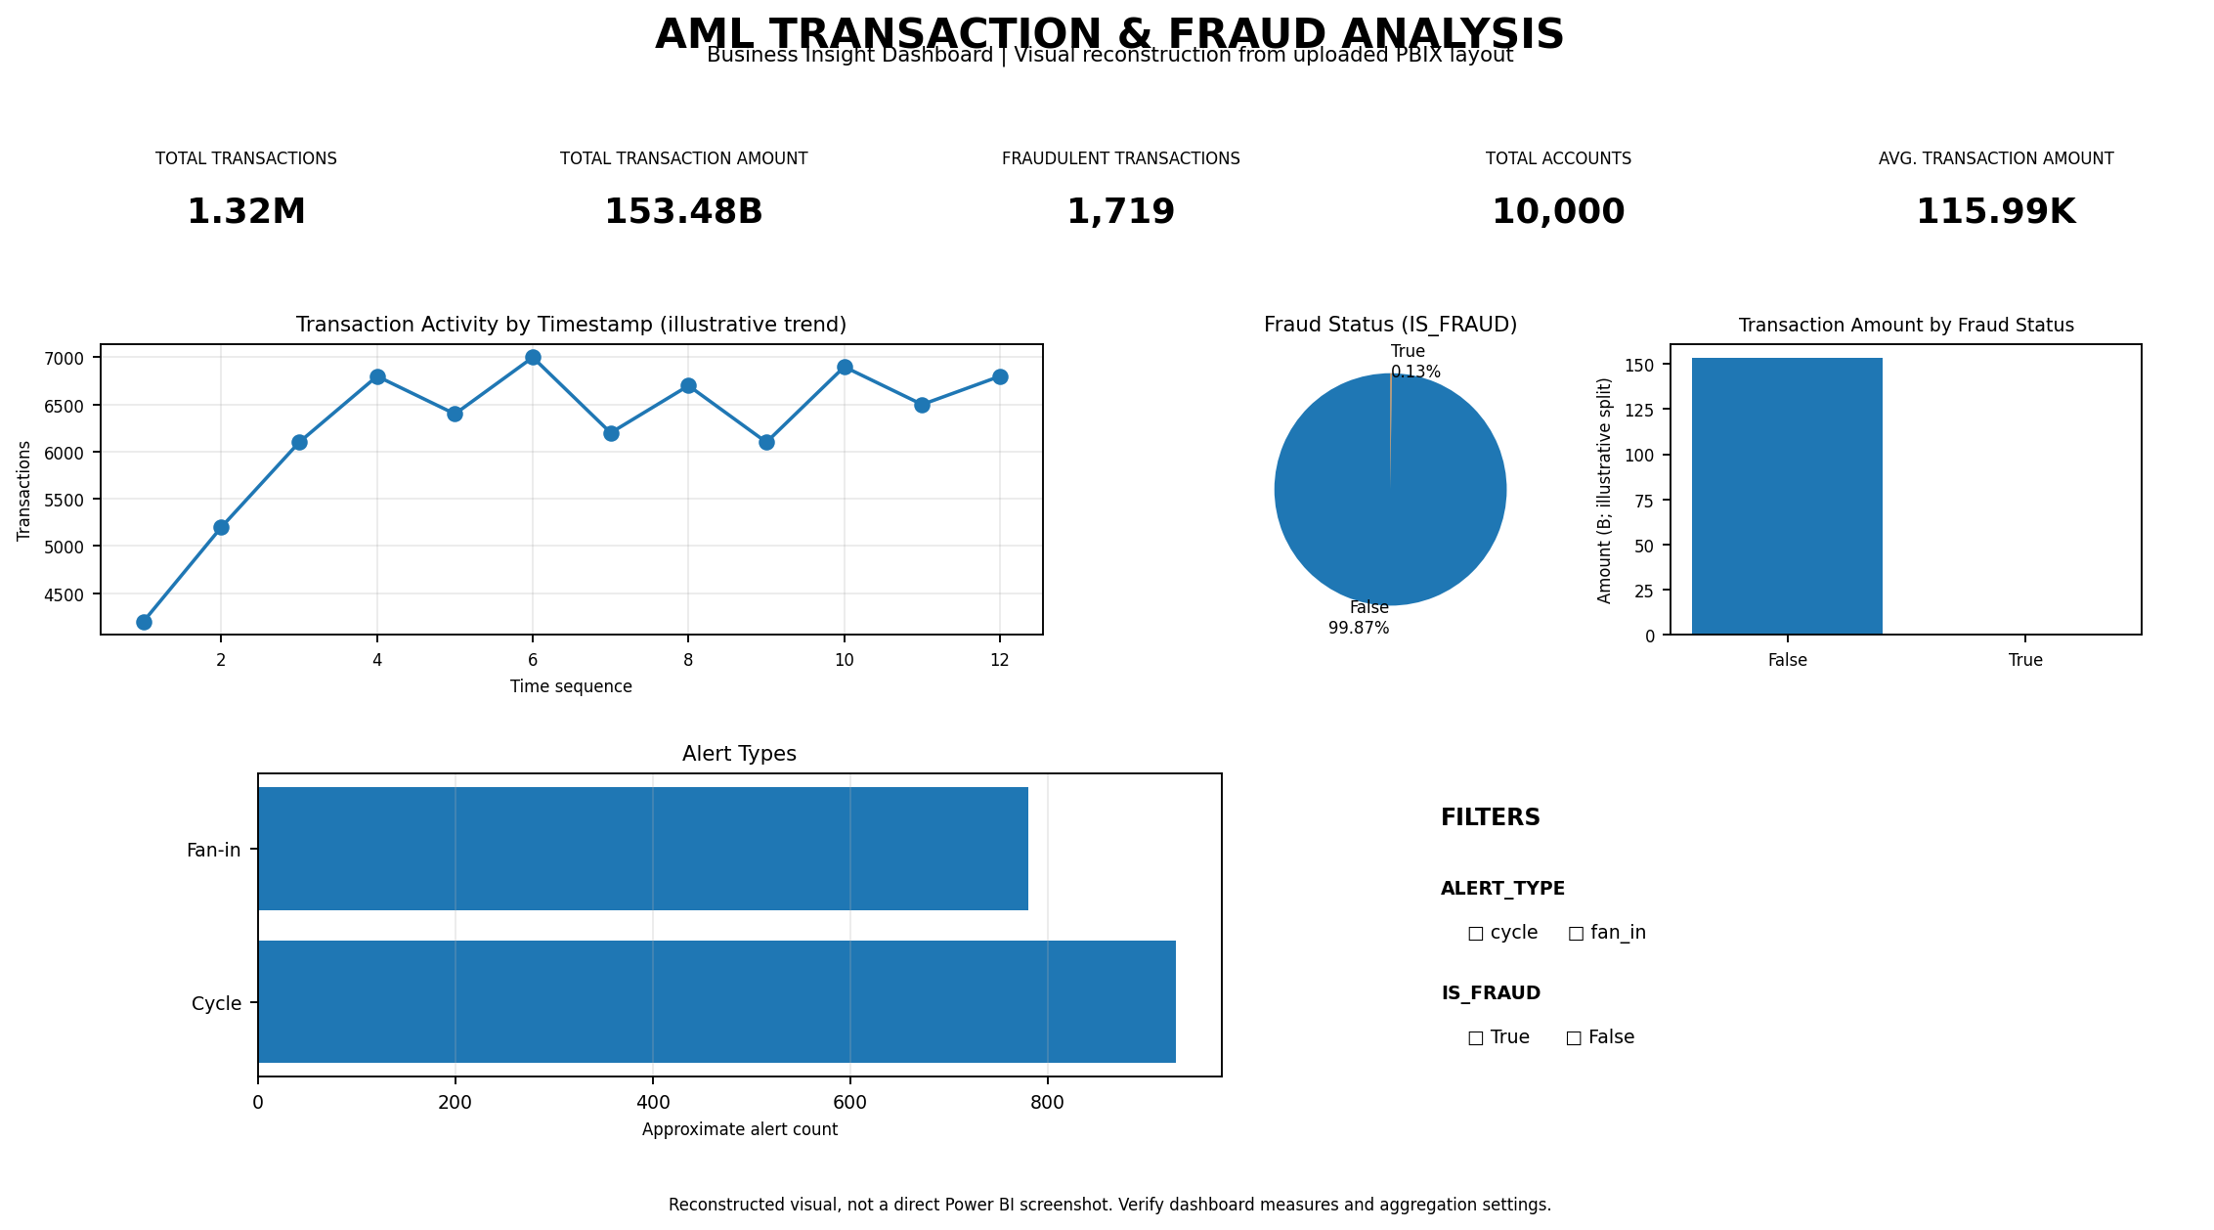

1. Title Page + Dashboard Screenshot
The dashboard presents AML transaction activity, fraud-status classifications, alert types, KPI cards, charts, and interactive filters. These views can support identification and prioritisation of activity that may warrant review. The image above is a visual reconstruction informed by the uploaded PBIX report layout and supplied values; it is not a direct screenshot captured from Power BI Desktop.
Report scope: Descriptive analysis only. Dashboard indicators are not findings of confirmed wrongdoing.

2. Overview of the AML Dataset
The uploaded Power BI file contains pages labelled KPI CARD, INTERACTIVE DASH BOARD, and TOOL TIP. Its layout includes KPI cards, a line chart, a column chart, a donut chart, a bar chart, and interactive slicers. The analysis is intended to review transaction volume and value, identify time-based patterns, and prioritise alerts for further investigation.
Key fields used: IS_FRAUD records the fraud-status classification; TIMESTAMP supports time-based analysis; ALERT_ID identifies alert records; and ALERT_TYPE categorises alert patterns.

3. KPI Interpretation
KPI | Dashboard Value | Interpretation
Fraudulent Transactions | 1,719 | Records classified as fraudulent; review the classification logic and underlying records.
Total Transaction Amount | 153.48 billion | Indicates a substantial aggregate transaction value; confirm currency, units, and aggregation.
Total Transactions | 1.32 million | Shows a high volume of transaction activity across the dataset.
Total Accounts | 10,000 | Indicates the account population represented by the dashboard.
Average Transaction Amount | 115.99K | Provides an average-value measure; confirm aggregation and treatment of blanks.
Together, the KPIs indicate high transaction throughput and a substantial aggregate transaction value, while a comparatively small number of records are classified as fraudulent. These measures should be read alongside alert details, timing, and account-level context.
Note: KPI values are based on the supplied screenshot/brief. Underlying calculations, currency units, filter context, and aggregation settings must be verified in Power BI before formal reporting or decision-making.

4. Fraud Status Analysis
The pie/donut chart using IS_FRAUD is described as showing approximately 99.87% of records as False and 0.13% as True. This represents the dashboard classification split and does not establish confirmed fraud. The bar/column chart comparing total transaction amount by fraud status may help compare values by classification; its measures and aggregation should be validated.
Insight: A low percentage classified as fraudulent does not mean low risk. A small number of high-value or connected transactions may still require investigation.

5. Transaction Activity Analysis
The line chart by TIMESTAMP is described as showing an initial increase, followed by fluctuations around 6,000–7,000 transactions. This may reflect changes in activity over time. Confirm the time interval, missing timestamps, and aggregation per period against the source data.
Insight: Time-based analysis can help identify unusual spikes, repeated patterns, or activity outside expected behaviour.

6. Alert Analysis
The horizontal bar chart indicates approximately 930 Cycle alerts and 780 Fan-in alerts. A cycle pattern refers to funds moving through a sequence of accounts, potentially returning to an earlier account. A fan-in pattern refers to funds from multiple sources converging into one account. Both patterns may have legitimate explanations and require context, transaction tracing, and supporting evidence.
Insight: Both alert types may warrant investigation based on risk and context; an alert is not automatic proof of fraud or money laundering.

7. Filter-Based Analysis
The dashboard includes an ALERT_TYPE filter (Cycle and Fan-in) and an IS_FRAUD filter (True/False). These controls can narrow the view to selected alert types or classifications. Confirm that relevant charts and KPI cards respond correctly, cross-filter interactions work as intended, and selections do not unintentionally exclude relevant records.

8. Key AML Insights
- The dashboard classifies approximately 0.13% of records as fraudulent; validate the classification against source records and rules.
- The dataset represents a large transaction volume of approximately 1.32 million transactions.
- The reported aggregate transaction amount is 153.48 billion, so currency and aggregation settings are important to verify.
- Cycle alerts appear more frequent than Fan-in alerts in the supplied dashboard values.
- Transaction activity reportedly increases initially and then fluctuates around 6,000–7,000 for the displayed intervals.
- Interactive filters can support focused review when chart interactions are configured correctly.
- Values, chart aggregations, field definitions, and underlying records require verification before formal use.

9. Recommendations
- Strengthen fraud monitoring by combining transaction patterns with customer and account risk profiles.
- Investigate high-priority alerts using transaction tracing, account relationships, supporting documents, and escalation criteria.
- Monitor activity continuously, using appropriate thresholds for unusual spikes, repeated transfers, and out-of-pattern behaviour.
- Improve fraud detection by validating rules and models against confirmed outcomes and emerging typologies.
- Use risk-based investigation to prioritise alert severity, transaction value, recurrence, and contextual factors.
- Improve dashboard accuracy by validating measures, data relationships, currency units, filter behaviour, and aggregation settings.
- Maintain proper records of alert review, supporting evidence, decisions, escalation, and closure rationale.
- Review false positives regularly to refine rules while maintaining sensitivity to genuine risk.

10. Conclusion
The dashboard provides a consolidated view of transaction volume and value, fraud-status classifications, time-based activity, and AML alert types. The reported figures suggest that a small share of records is classified as fraudulent while transaction volume and aggregate value are substantial. Cycle alerts appear more frequent than Fan-in alerts, but patterns require context before conclusions can be reached.
KPI cards and the pie/donut chart, bar/column chart, line chart, and horizontal bar chart help reviewers compare classifications, transaction values, activity over time, and alert frequency. Filters may support focused analysis. Calculations, aggregation settings, currency units, source records, and filter interactions should be checked in Power BI before formal use.
Disclaimer: Dashboard alerts are indicators for investigation, not conclusive proof of money laundering or fraud. Transactions and related account activity must be reviewed using appropriate evidence and institutional procedures before any conclusion is made. KPI values are based on the supplied screenshot/brief and require verification of calculations and aggregation settings.

